Technical Documentation
For
C4D Enterprise System

ITECH 7404
PROJECT 2

Prepared by Yue KANG
30351593
5/30/2019

Table of Contents
1 Introduction 3
2 Software Quality 3
3 Software Packaging 4
4 Installation 6
5 User manual 13
6 Developer manual 23
7 Conclusion 23

Introduction
The responsive website is designed for Champions4Dance Dancing Studio, a start-up dancing studio in Sydney. The purpose of the website is for the studio cut off the paper work, and increase the efficiency in different profile management. Besides, the website provides the function for registered students to check attendance, which will serve as a proof to attend the class.
Admin can use all the functions of the website, such create, read, upload and delete all the user cases. Besides, admin can administrate the sign-in cases, depending on necessities. Therefore, schedule and business intelligence are served to the client. Courses management will have options to create records, update records, read records and delete records depending on different authentication. What’s more, Attendance Management will be provided to all registered users to make them check attendance by themselves.
The main user of the web application will be the administrator because this is basically designed as information management system for the admin. The web can be viewed in PC browsers and mobile portals.

Software Quality
  - Software
According to the IEEE Standard 729-1983, software is "computer programs, procedures, rules, and possibly associated documentation and data pertaining to the operation of a computer System." Note: the definition of software includes not only the computer code, but also the documentation that goes with it. This definition encompasses both in-line comments in the code as well as specifications, design documents, client manuals, and maintenance guides. Good software must not only work well but must be documented well, too.

  - Software Quality
Software Quality - The SQA literature defines software quality as the ability of the software to comply with defined requirements. This differs from a definition based on the fitness for use of the software. This definition of quality as compliance defined requirements places anyone involved in SQA in the position of operating with something other than opinion and experience. Defined requirements act as the foundation for determining the level of quality. Emphasis therefore needs to be placed on establishing the requirements in the first place rather than on determining what to do after the damage is done and the system works inadequately. This definition of quality implies two areas of action for the SQA function: 1 Ensure that the product correctly meets client needs. 2. Verify that reasonable steps were taken to ensure the quality of the product. These two areas imply that a system must also meet a number of software quality factors or characteristics, in addition to performing its general processing function. As previously mentioned, the goal of quality is to meet specified requirements rather than achieve an absolute level of quality. The purpose is not to guarantee 100% reliability or zero defects; rather, it is to verify that every reasonable step has been taken during the life cycle to achieve a desired level of quality in the end product.

  - Six Sigma
Six Sigma is a mantra that many of the most successful organizations in the world swear by and the trend is getting hotter by the day. So much so that corporations like GE insist that every project be a Six Sigma project. The Six Sigma methodology has indeed made a tangible difference to the bottom lines of many corporations and they have the numbers to prove it because Six Sigma requires constant and consistent measurement.
While the Six Sigma body of knowledge provides great tools for improving product and process quality (DMAIC) and even for developing new products (DFSS and DMADV), some work is still needed for managing software projects. The fit between Six Sigma and software project management methodology is not always obvious. Some of the common Six Sigma tools don’t easily lend themselves to software projects. Part of the reason is possibly that engineering and manufacturing have evolved over hundreds of years, software development is only a few decades old. Also, software development tends to teeter between an art form and an inexact science. Practitioners in the software development arena are not always comfortable or adept with rigorous quantitative analysis.
  - CMM level
The Capability Maturity Model (CMM) is a methodology used to develop and refine an organization's software development process. The model describes a five-level evolutionary path of increasingly organized and systematically more mature processes. CMM was developed and is promoted by the Software Engineering Institute (SEI), a research and development center sponsored by the U.S. Department of Defense (DoD). SEI was founded in 1984 to address software engineering issues and, in a broad sense, to advance software engineering methodologies. More specifically, SEI was established to optimize the process of developing, acquiring, and maintaining heavily software-reliant systems for the DoD. Because the processes involved are equally applicable to the software industry as a whole, SEI advocates industry-wide adoption of the CMM.
The CMM is similar to ISO 9001, one of the ISO 9000 series of standards specified by the International Organization for Standardization (ISO). The ISO 9000 standards specify an effective quality system for manufacturing and service industries; ISO 9001 deals specifically with software development and maintenance. The main difference between the two systems lies in their respective purposes: ISO 9001 specifies a minimal acceptable quality level for software processes, while the CMM establishes a framework for continuous process improvement and is more explicit than the ISO standard in defining the means to be employed to that end.

CMM's Five Maturity Levels of Software Processes
- At the initial level, processes are disorganized, even chaotic. Success is likely to depend on individual efforts, and is not considered to be repeatable, because processes would not be sufficiently defined and documented to allow them to be replicated.
- At the repeatable level, basic project management techniques are established, and successes could be repeated, because the requisite processes would have been made established, defined, and documented.
- At the defined level, an organization has developed its own standard software process through greater attention to documentation, standardization, and integration.
- At the managed level, an organization monitors and controls its own processes through data collection and analysis.
- At the optimizing level, processes are constantly being improved through monitoring feedback from current processes and introducing innovative processes to better serve the organization's particular needs.
  - Test Process
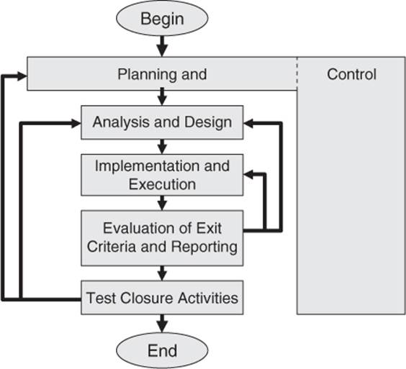

Software Packaging

  - Detailed technical information
The C4D Enterprise System was developed by several programming languages. The backend includes controllers and API controllers was developed by C# language. The frontend was developed in HTML, CSS, javascript, and distinct bootstrap. The database uses Sql Server. The server is IIS. The deploy environment is Azure Portal.
  - Contents of Software package information
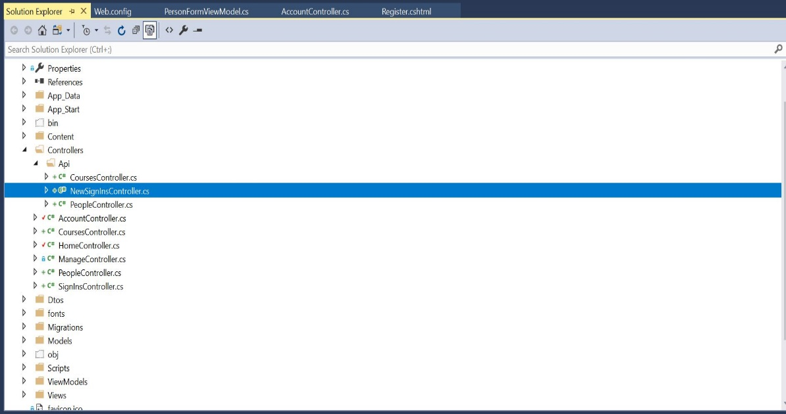
Name | Introduction
Properties | Information of publish files and assembly information
References | All the references used by different classes
App-data | Mdf file of the database
App-start | Configs of the application
Content | Javascripts components and bootstrap themes
Controllers | View controllers and API controllers
Dtos | Data transfer object files
fonts | fonts
Migration | The application takes “code first” migration method, the file contains all the migration history
Models | Models of all objects
Scripts | Scripts of Javascripts and bootstrap
ViewModels | View models contains the models which need to be imported into views
Views | The front view of the application
Web Config | Web configurations includes connection strings
Others | Other generic files and configuration

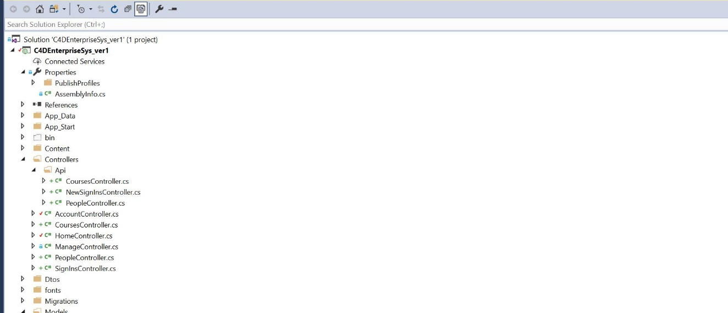

Name | Introduction
Controllers | The controller package of all controllers include api controllers
CourseController(api) | The api controller of course management
NewSignInsContrller(api) | The api controller of attendance management
PeopleController(api) | The api controller of people management
AccountController | The controller of account management
CourseController | The controller of course management
HomeController | The controller of different pages
ManageController | The controller of authorisation and authentication
PeopleController | The controller of people management
SignInController | The controller of attendance management

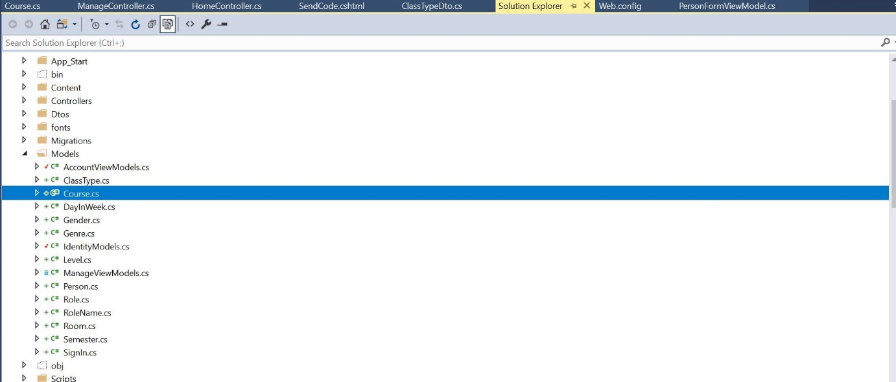

Name | Introduction
Models | The container contains all of the data which needs to be transferred to database
ClassType | The model of classtype
DayInWeek | The model of dayinweek
Gender | The model of gender
Genre | The model of genre
IdentityModel | The generic identitymodel
Level | The model of level
ManageViewModel | The generic manageviewmodel
Person | The model of person
Role | The model of role
RoleName | The model of rolename
Room | The model of room
Semester | The model of semester
SignIn | The model of signin

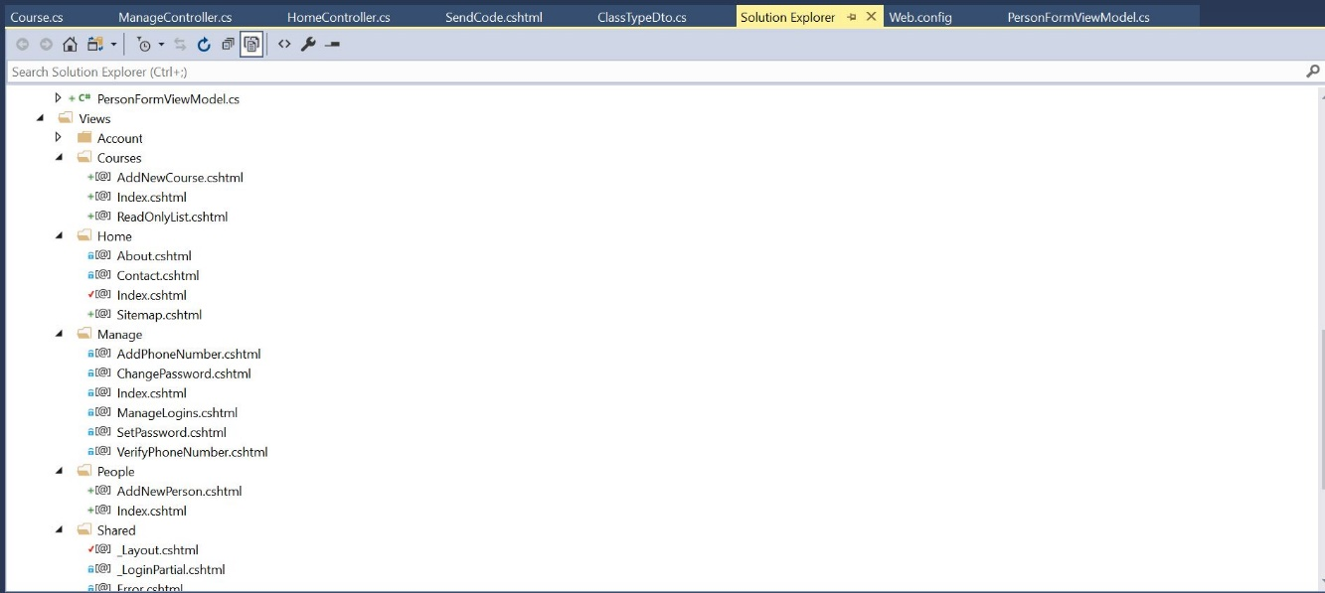

Name | Introduction
Views | The views of different pages
AddNewCourse(Courses) | The page of add new course in courses management
Index(COurses) | The page of add index in courses management
ReadOnlyList(Courses) | The page of read only list in courses management
About(Home) | The page of about at home
Contact(Home) | The page of contact at home
Index(Home) | The page of index at home
Sitemap(Home) | The page of sitemap at home
AddPhoneNumber(Manage) | The page of add phone number
ChangePassword(Manage) | The page of change password
Index(Manage) | The page of index in login management
SetPassword(Manage) | The page of set password in login management
AddNewPerson(People) | The page of add new person in people management
Index(People) | The page of index in people management
Layout(Shared) | The shared layout
LoginPartial(Shared) | The shared login partial layout

3.3Requried third party software

Microsoft Azure Portal
Microsoft Azure is a cloud computing service created by Microsoft for building, testing, deploying, and managing applications and services through Microsoft-managed data centers. It provides software as a service (SaaS), platform as a service (PaaS) and infrastructure as a service (IaaS) and supports many different programming languages, tools and frameworks, including both Microsoft-specific and third-party software and systems.
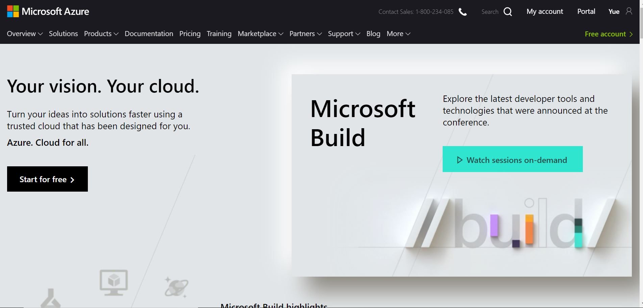

Visual Studio Community(2016)
Microsoft Visual Studio is an integrated development environment (IDE) from Microsoft. It is used to develop computer programs, as well as websites, web apps, web services and mobile apps. Visual Studio uses Microsoft software development platforms such as Windows API, Windows Forms, Windows Presentation Foundation, Windows Store and Microsoft Silverlight. It can produce both native code and managed code.
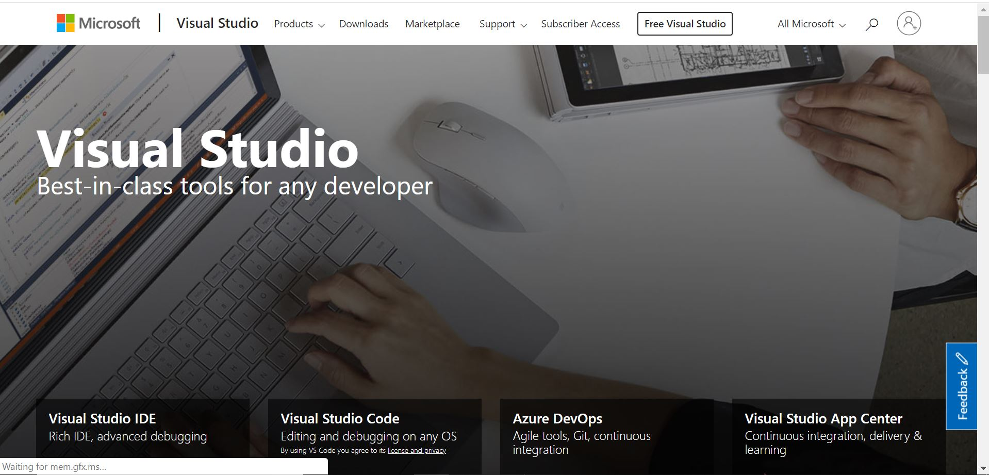

MS SQL SERVER(2017)
SQL Server Management Studio (SSMS) is a software application first launched with Microsoft SQL Server 2005that is used for configuring, managing, and administering all components within Microsoft SQL Server. It's the successor to the Enterprise Manager in SQL 2000 or before. The tool includes both script editors and graphical tools which work with objects and features of the server.
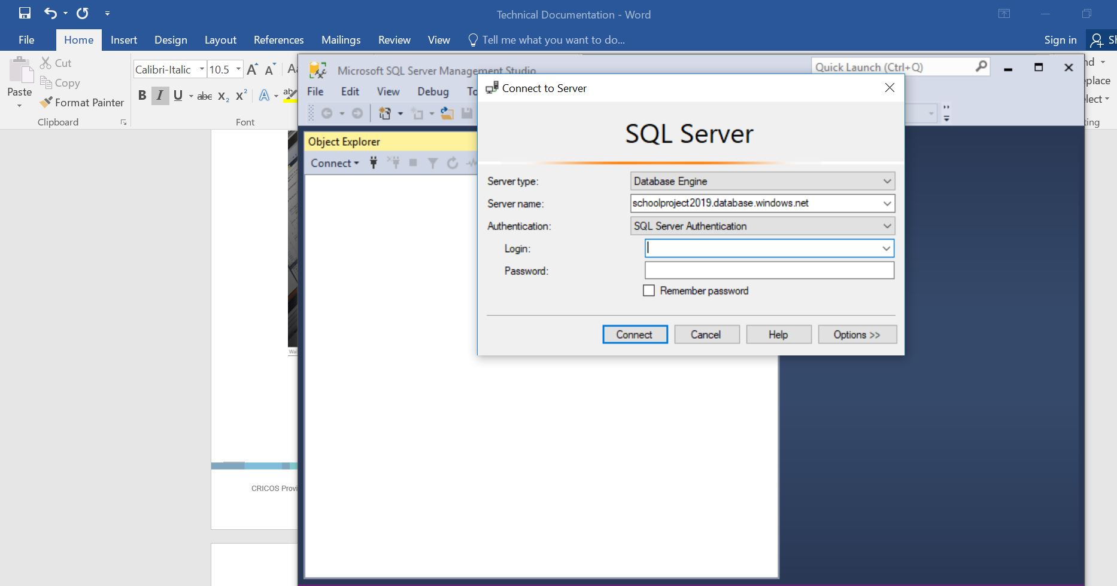

Installation

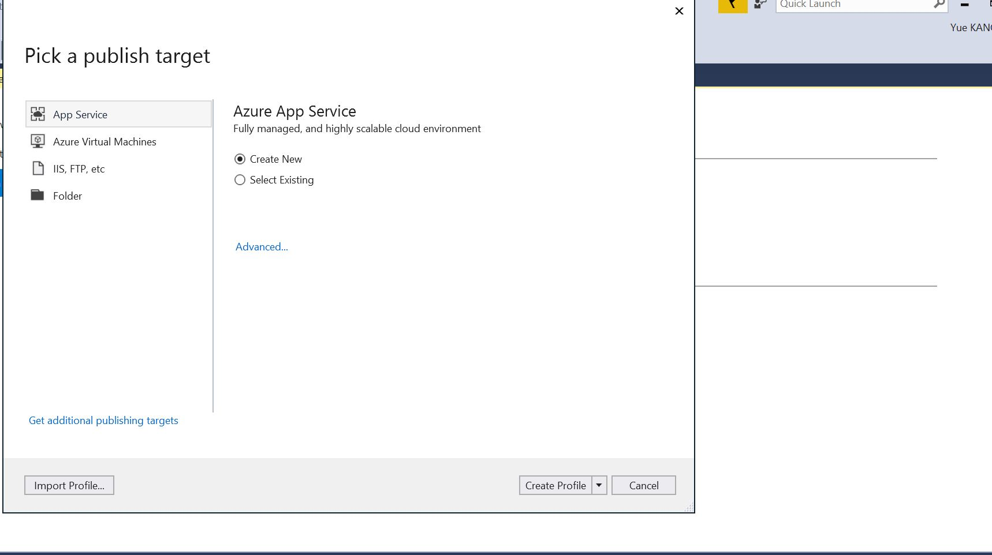

- First checking everything is Okay, right-click application, go to publish > app service > create new file.
- The app can create different profiles due to different purposes.

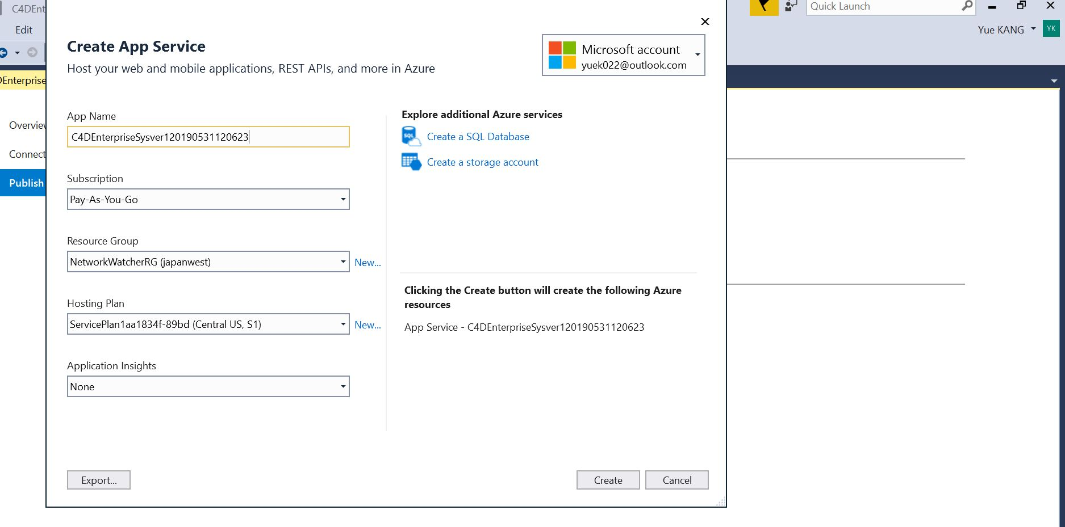
- Fill the app name or use the default name
- Choose subscription (which is really expensive!)
- Choose resource group
- Choose hosting plan
- Choose application insight (which is none)

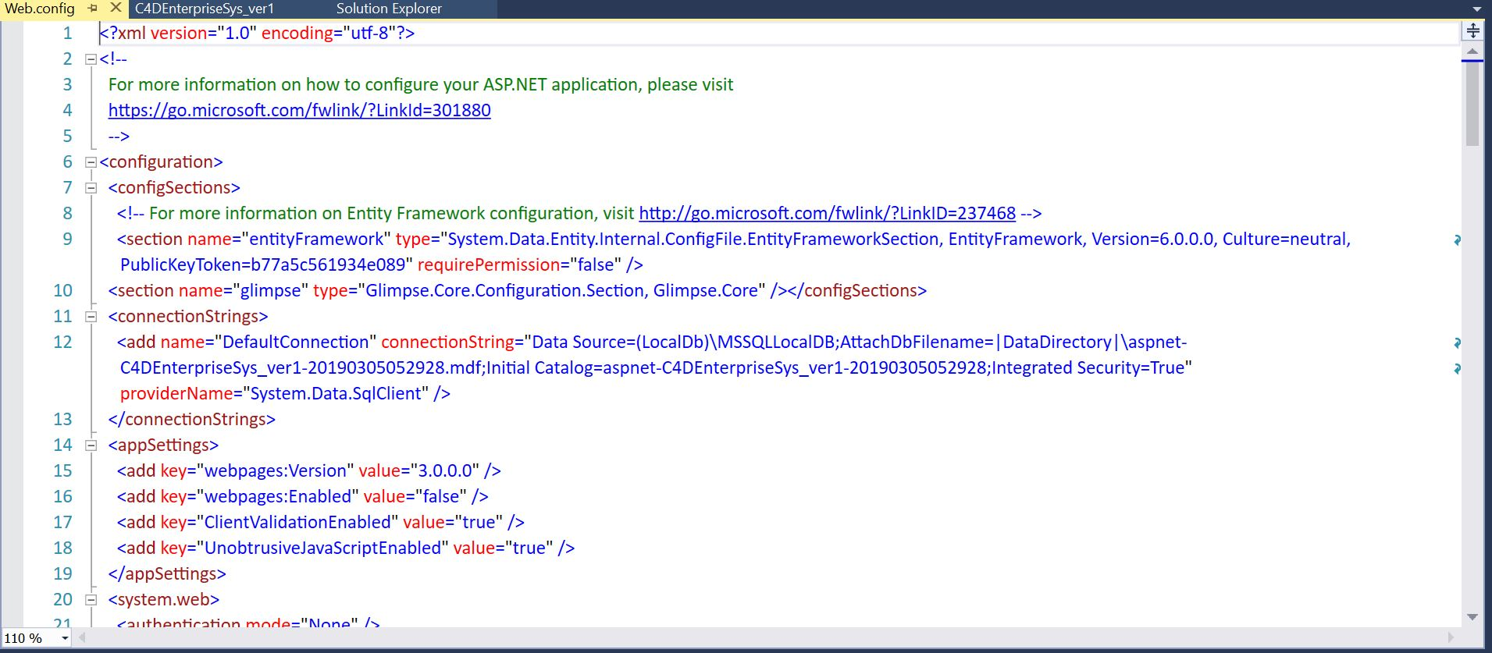

- Deploy the database with sql server
- Change the connection string of the online database before deployment.
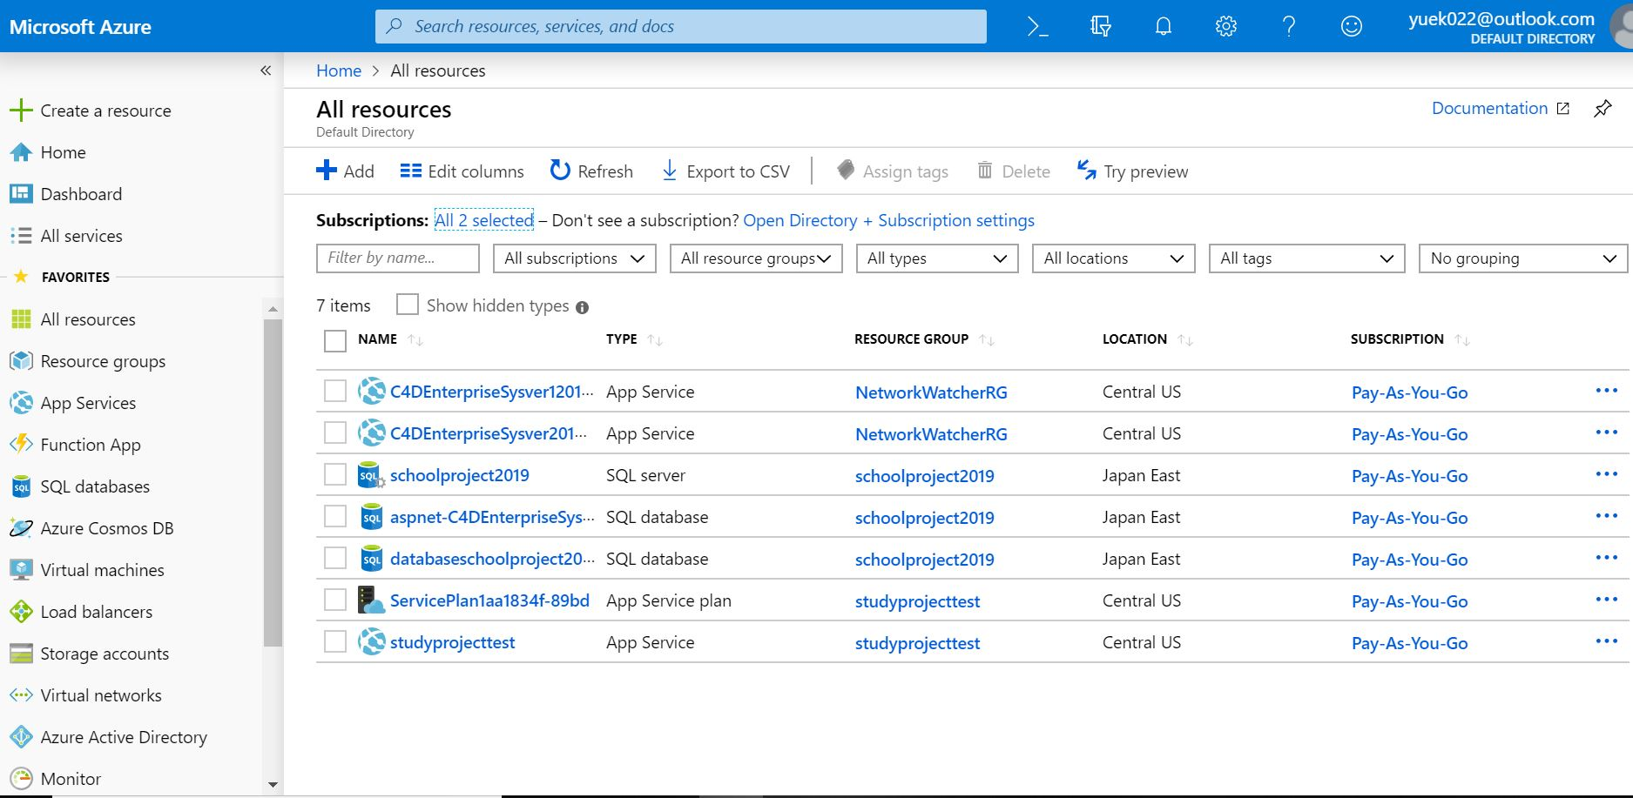

- After publish successfully, check the service plan and the application.
- The service will stop if there is no subscription.
- Check the details of online website.
Web site URL (only functions in week 12 demo)
https://c4denterprisesysver20190601.azurewebsites.net

User manual

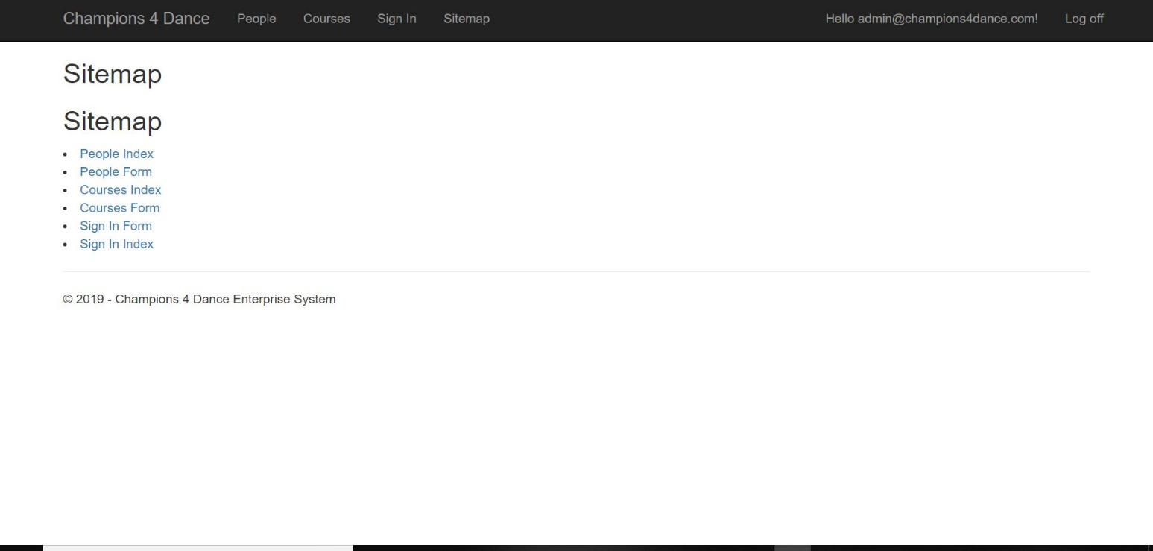
Number |  | Group | User Stories | Scenarios
1 |  | View | As I user, I can view the index of the website, some pages are open to authorized users. | When entering the website, all the elements of the index can be displayed to the users, includes sitemap.

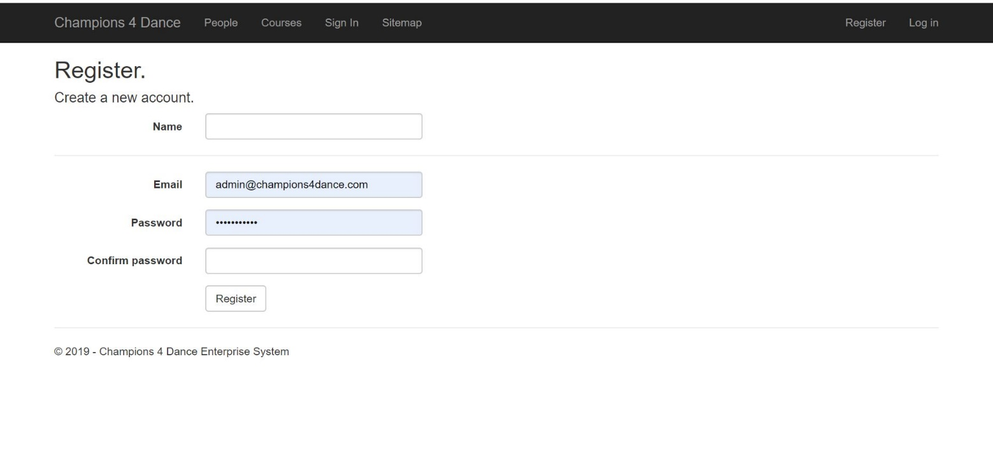
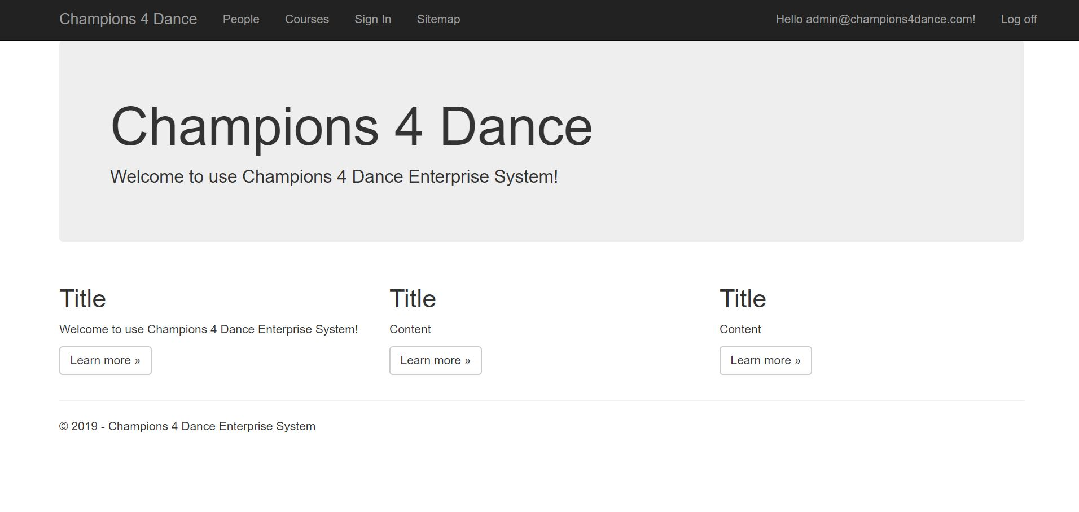

2 |  | Register | As a user, I can register as the RU to use the specified functions of the website with personal email. | When selecting register, users can register the account with the his own email and the right corner will show his email.
3 |  | Login | As a user, I can login after sign out. | Users can select log out to leave the account, and select log in to login to the account.

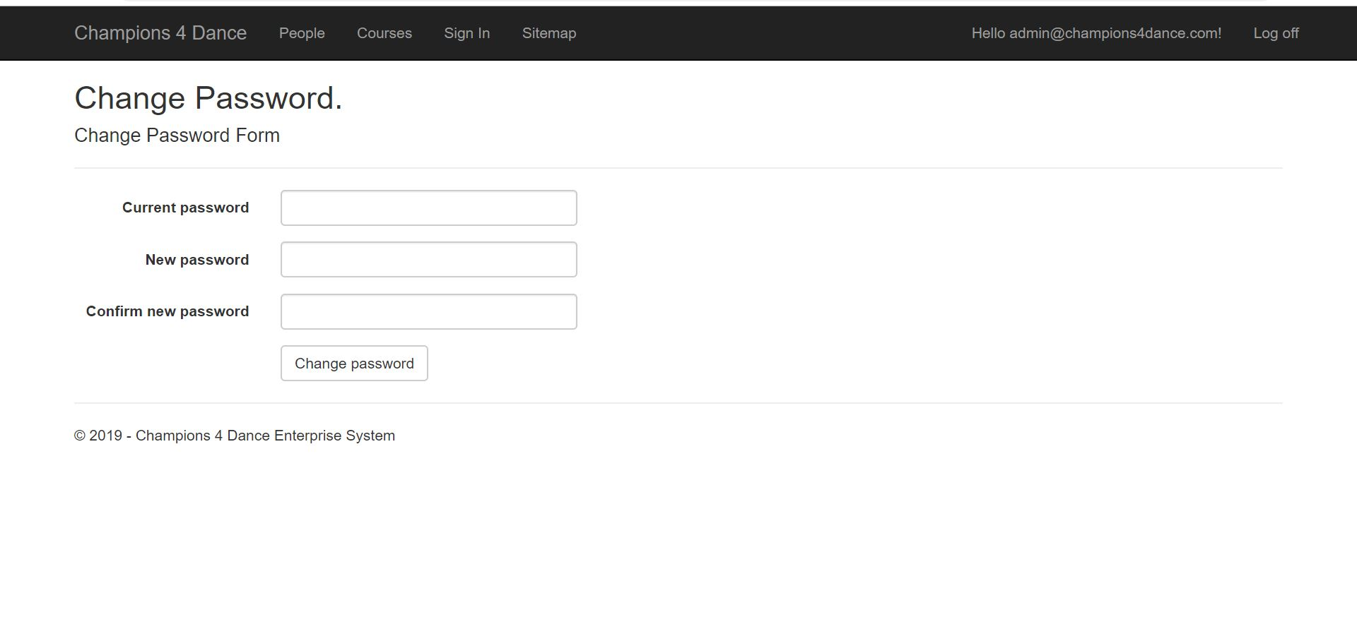
4 | Login | As a user, I can change the password after login the account. | Users can select change password to make modification on the password.
5 |  | View | As a user, I can use the specified functions assigned to the user group. | Different users have different authorization of the software.  (Admin can do the course management, but registered users can only view the courses)

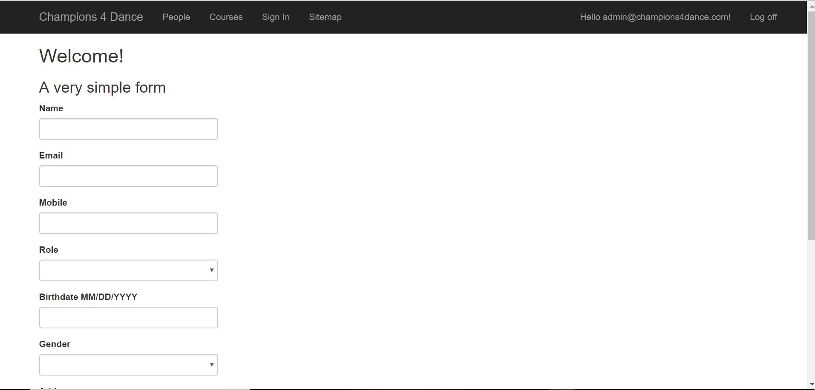

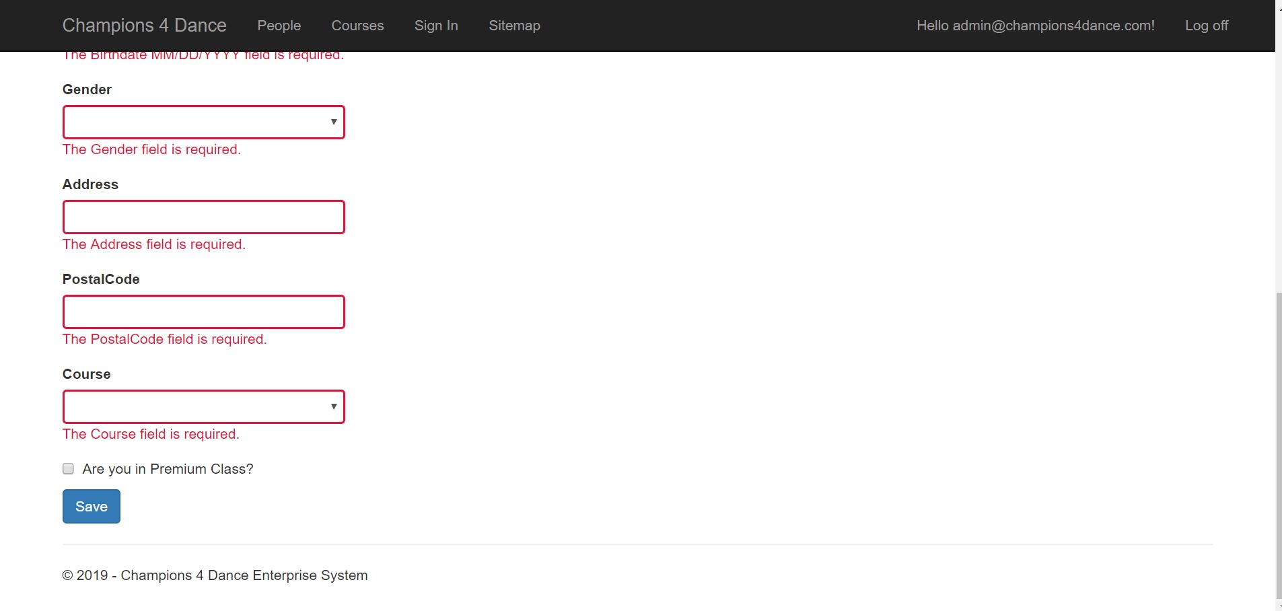

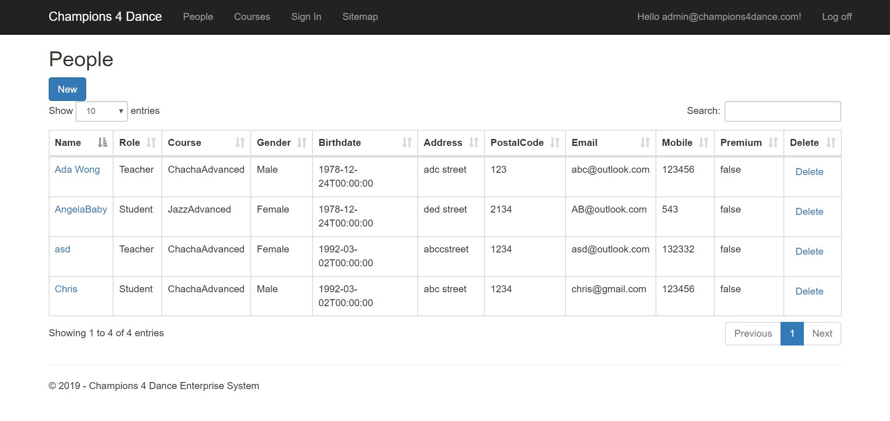

6 |  | People Management | As an Admin, I can Add person on the People management. | Admin can select new, then start add individual information of different customers.
7 |  | People  Management | As an Admin, I can edit person after add the person to the database. | Admin can select the name of the person, then start edit the information of the person.
8 |  | People  Management | As an Admin, I can validate personal information after select submit. | Admin can select submit to validate the information, if the data is not valid, the submission will fail and the information box will hightlight.
9 |  | People  Management | As an Admin, I can select the number of entries from the index | Admin can select the entries to show the number of records. (10,20 or 50)
10 |  | People Management | As an Admin, I can use search bar to filter information | Admin can filter information by the search bar, such as name, address, gender, course and so on.[the feature of the application!]
11 |  | People  Management | As an Admin, I can sort data according to my purpose | Admin can sort data by selecting the title of different categories.
12 |  | People  Management | As an Admin, I can select delete to remove record. | Admin can select delete to delete data from the people management.
13 |  | People  Management | As an Admin, I can go to different pages. | Admin can go to different pages through previous and next.

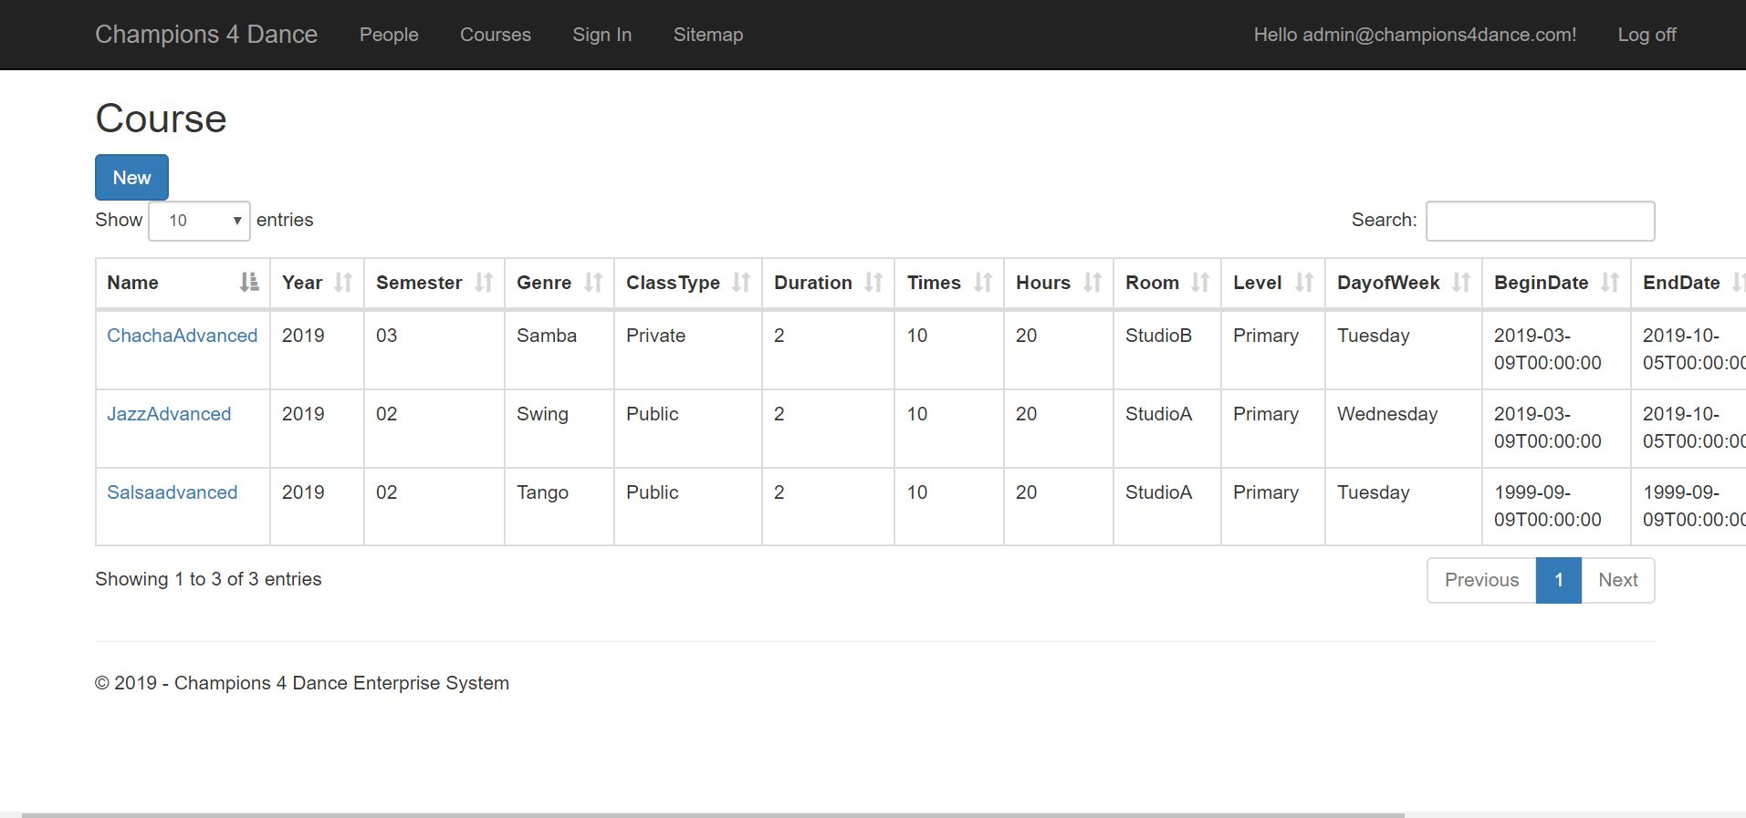
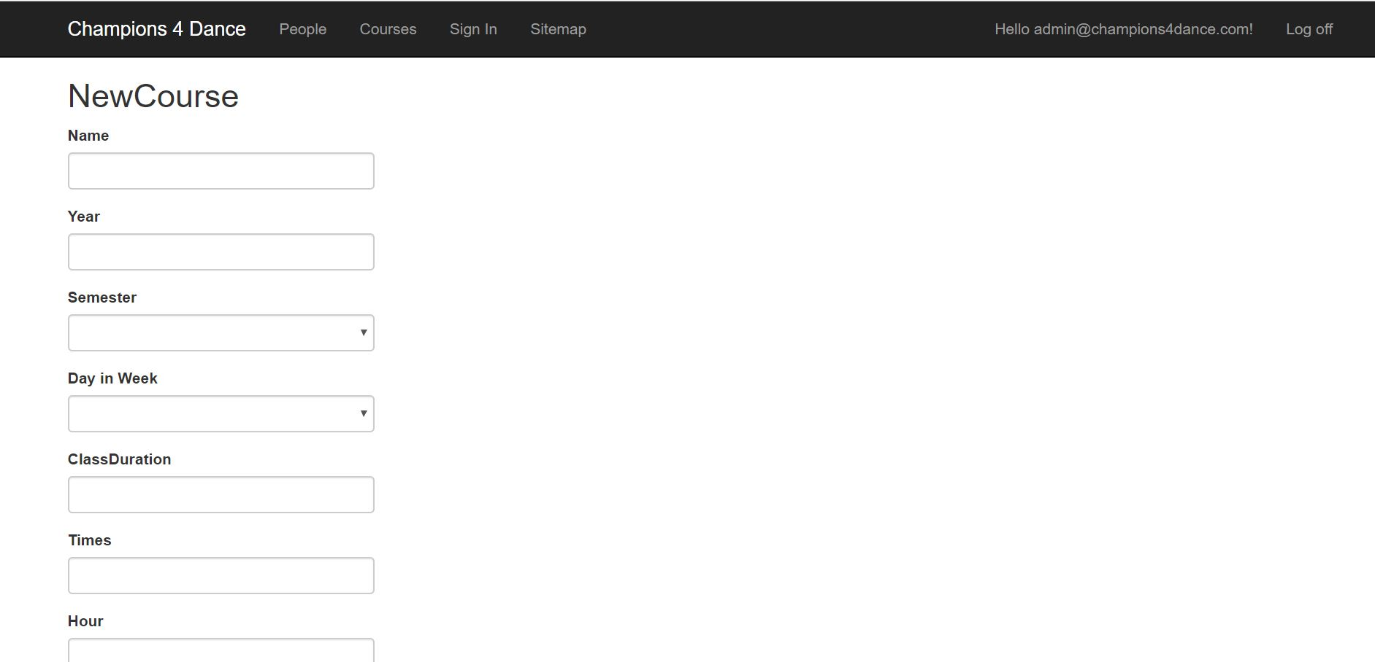

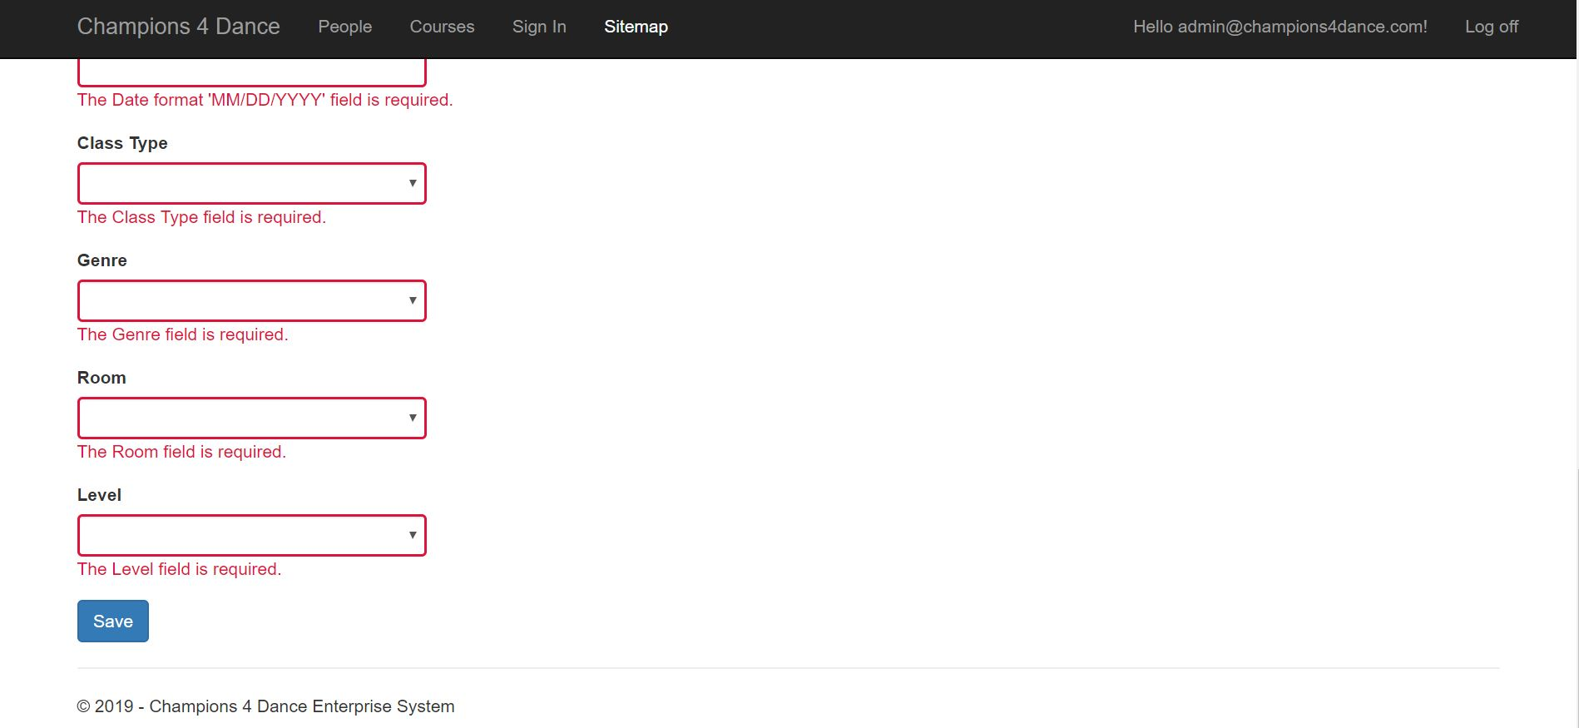

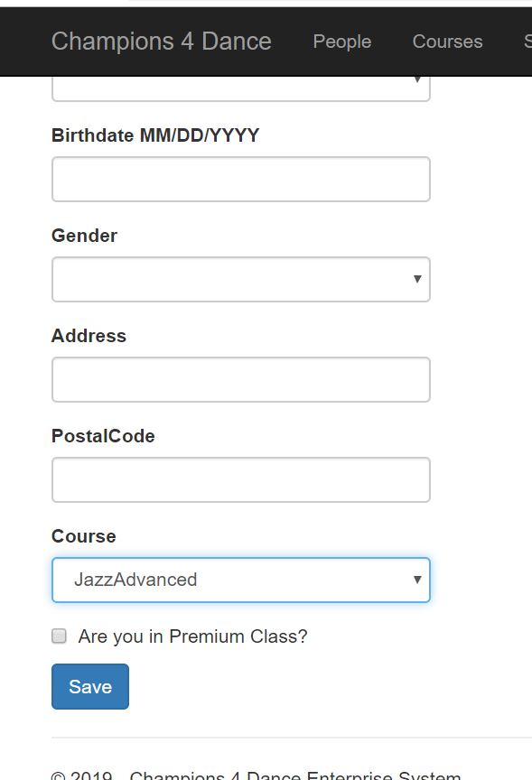

14 |  | Course Management | As an Admin, I can add course on the courses management. | Admin can select new, then start add course procedure.
15 |  | Course  Management | As an Admin, I can edit course after add the course to the database. | Admin can select the name of the course, then start edit the information of the course.
16 |  | Course  Management | As an Admin, I can validate course information after select submit. | Admin can select submit to validate the information, if the data is not valid, the submission will fail.
17 |  | Course  Management | As an Admin, I can select the number of the entries on the index, | Admin can select the entries to show the number of records of courses.
18 |  | Course Management | As an Admin, I can use search bar to filter information | Admin can filter information by the search bar, such as name and so on.
19 |  | Course  Management | As an Admin, I can select the title to sort data. | Admin can select title of different categories to sort data.
20 |  | Course  Management | As an Admin, I can select delete to remove record in the course management. | Admin can select delete to delete data from the course management.
21 |  | Course  Management | As an Admin, I can select the all the courses from people management. | All the courses can be view and selected in the course selection after they are created.

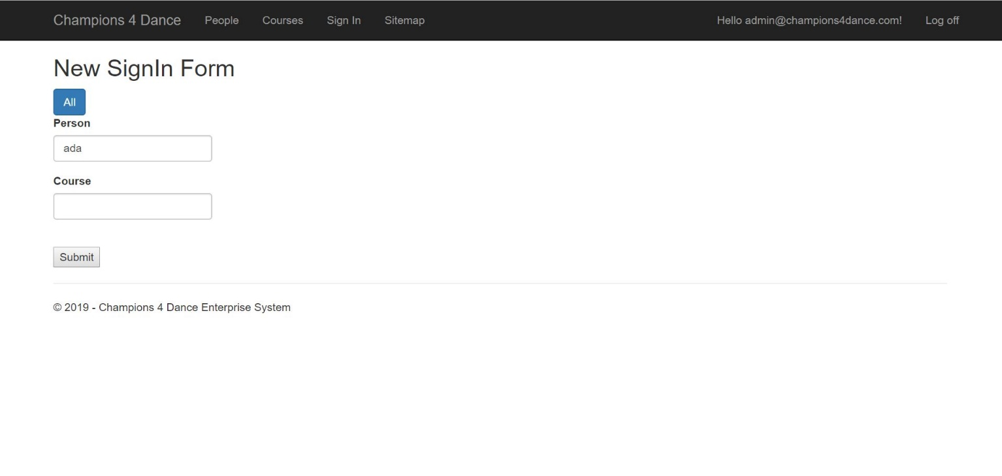
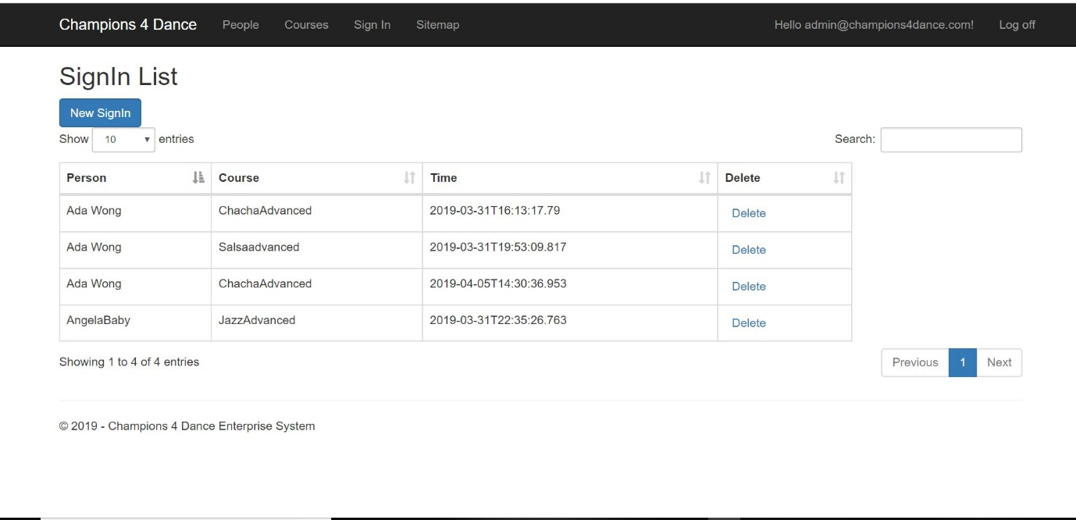

22 |  | Attendance  Management | Admin can view the new sign-in page through navigation bar and sitemap. | Admin can select new SignIn to load on the sign-in page.
23 |  | Attendance  Management | Admin can type name in the textbox, then text box will show the name and course automatically. | Admin can type name in the textbox for name, then text box will show the name automatically. (This function is for filtering information, one of the feature of the application)
24 |  | Attendance  Management | Admin can type course in the textbox, then text box will show the course automatically. | Admin can type course in the textbox for course, then text box will s. (This function is for filtering information, one of the feature of the application)how the course automatically.
25 |  | Attendance  Management | Admin can validate the information after submitting the table. | Select submit. IF name and course is not in database, the submission will fail. (there is a validation here)
26 |  | Attendance  Management | As an Admin, I can view all the attendance records. | Admin can select view all, to see all the records of Attendance of students.
27 |  | Attendance  Management | As an Admin, I can search all the attendance records. | Admin can search all the attendance records through the search bar.
28 |  | Attendance Management | As an Admin, I can sort all the attendance records according to name, course and time. | Admin can do this by selecting the title of different categories.
29 |  | Attendance  Management | As an Admin, I can delete the duplicated sign in record. | Admin can do this by selecting delete and refresh the page.(Refresh the page is compulsory)
30 |  | Attendance | As an Admin, I can create more than one, up to three sign-in records at the same time. | After add name, Admin can do this by add up to three courses which are existed in the database. (Course can be the same).

Developer manual
5.1 General introduction of MVC framework
The application was developed in asp.net MVC architectural pattern. MVC pattern is listed as follow.
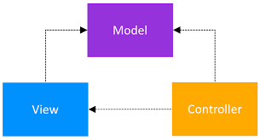
MVC is one of the architectural implementing user faces. MVC frame work is designed in 1970s and is widely adopted in web. And as a result, MVC has been applied in many languages, such as asp.net ruby on rails and express.
In MVC model, Model represents application and behaviour in terms of its problem domain, and independent of the UI.
For example, there are four main management designed in the application. They are people, courses, attendance and login.
They have classes and models which purely represents the states. They are not tied closely to the application, which means we can use them separately in different fields.
View represents the HTML mark-up that we display to the users.
Controllers are responsible for handling an HTTP request.
For example, if the pseudo URL is http:// c4ddance.com/courses
First of all, when we send a request to the above URL, a controller will handle the request. The controller will get all the courses from the database with the model, and put them in a view. And return the view to the browser and clients.
So, with this architectural, each part is individually dealing with different tasks. It means a better separation of concerns and better maintainable of the codes.
Another import thing in the framework which has not been mentioned is router.

Router

When a request comes to the application, a controller will be selected to handle the request. Selecting the right controller is the duty of router. A router is based on some rules and with the above URL, the request will be sent to the courses controller. In asp.net, an action in a controller is responsible for handling the request.
Following is the example of an action in the course controller (just the controller, not API controller).

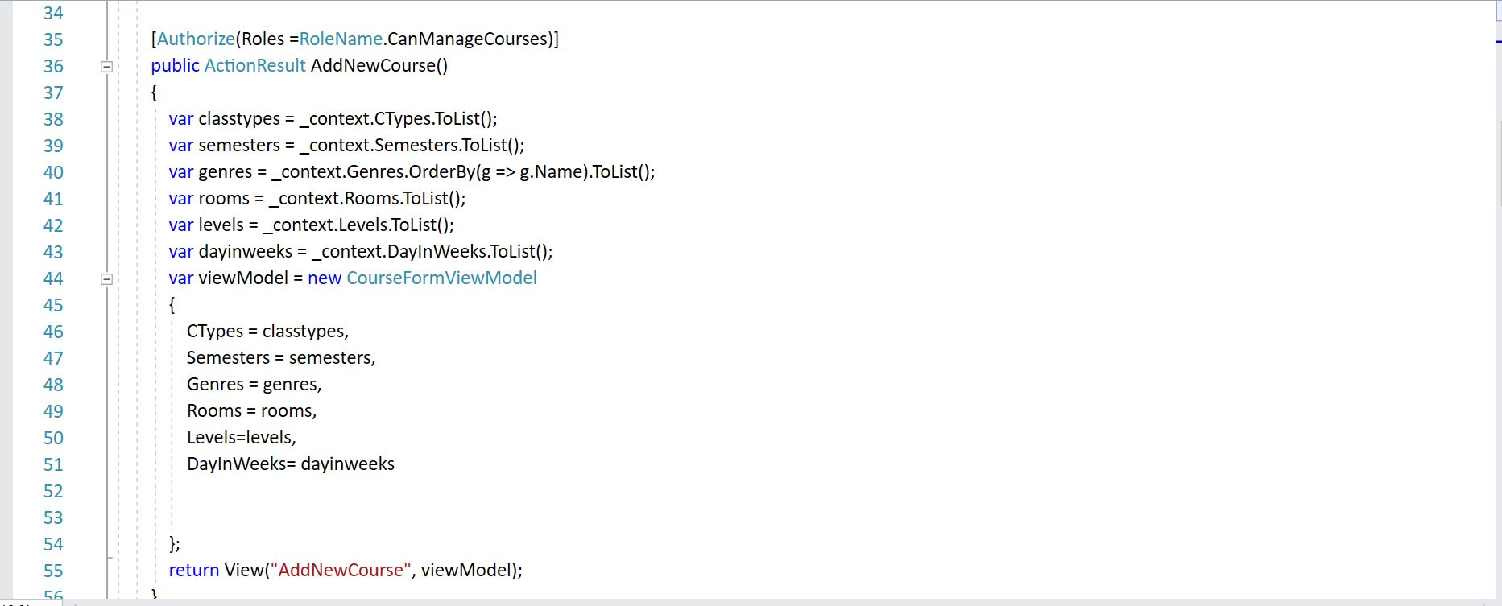

5.2 Database Construction.
The developer uses the code-migration method to do the database. The benefits of code-migration is that the Code migration is when programs are moved from one machine to another, often moving parts of its execution environment along with it. The intent is for the transferred program to continue execution on the target machine. Here is the migration history.
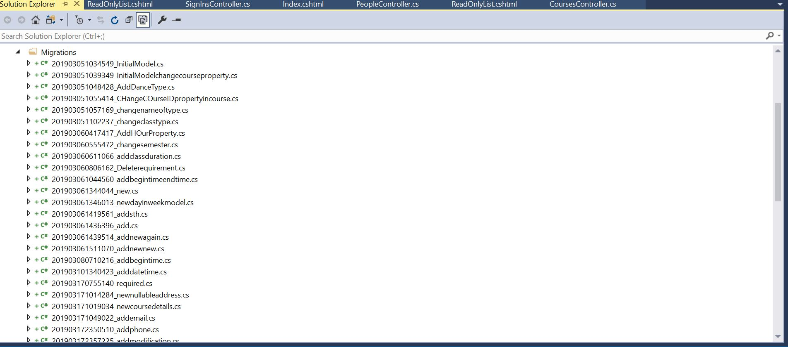

5.3 Other developer notes

- The Api name uses camel notation. And the RESTful Api development environment uses postman.
- Since the construction of database uses code-first migration, after building the code in model, please use package-manager to transfer the code. Please install entity-framework 2017 before doing the code migration. The application uses lambda expression and LINQ in doing the CRUD between the application and database. There is no specific SQL sentence.
- For extension. Please write different controllers and corresponding views when you want to do the extension.
(and please check the comment on the code).

- The application uses the default configuration of the MVC framework. For others, please read the code in the package.
5.4 List of classes
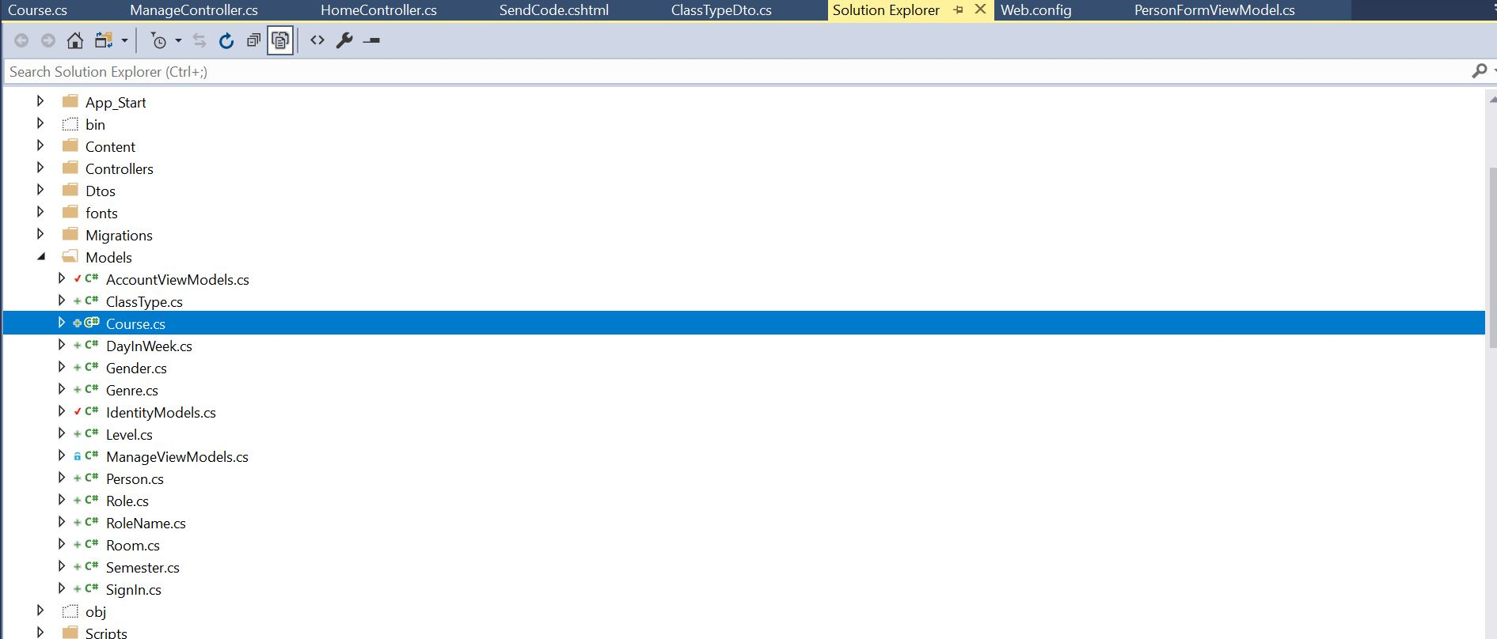
5.5 Programs(controllers)
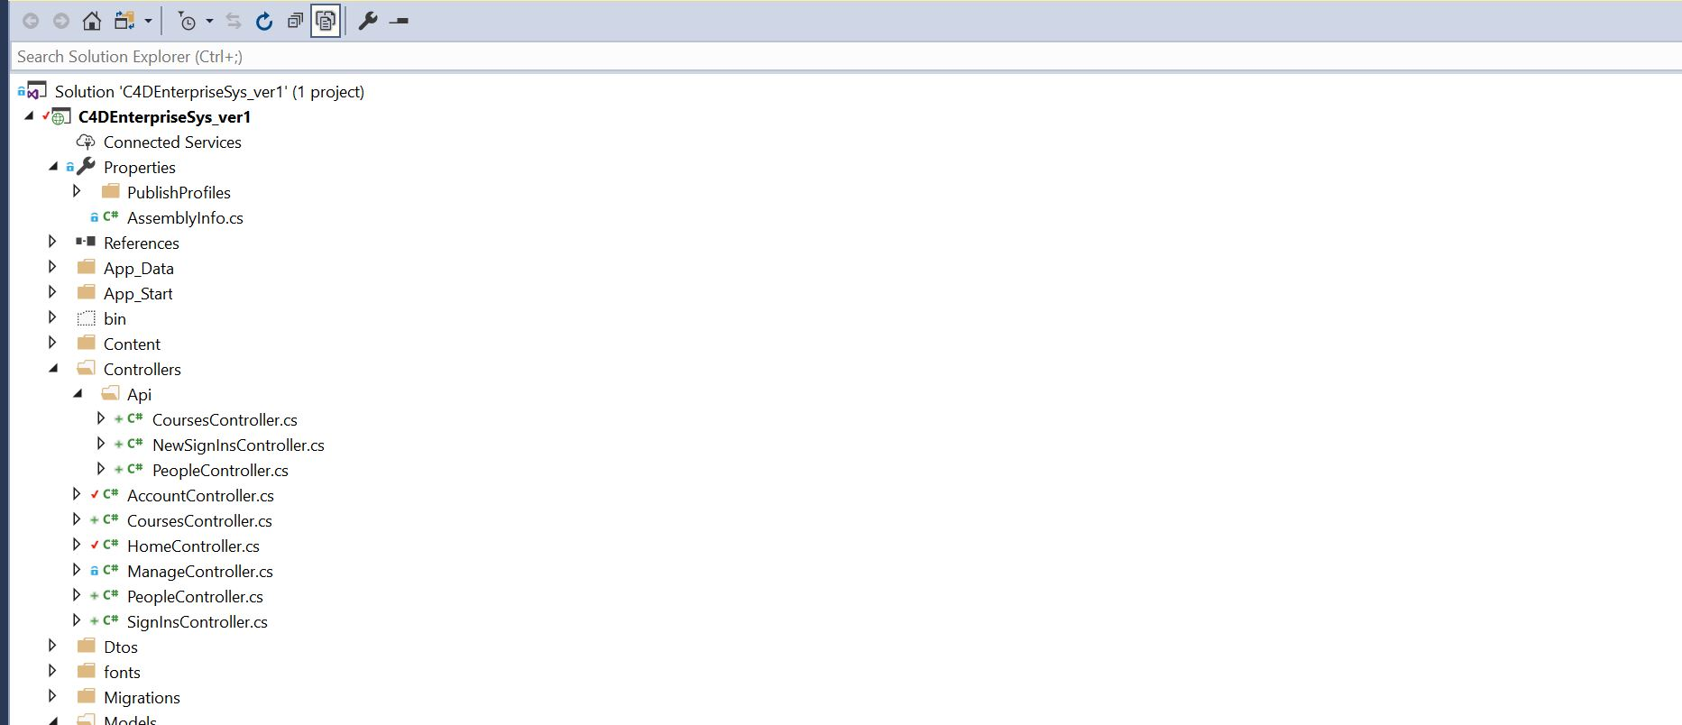
5.6 Functionality(Example of api People Controller and People Controller )
People Controller API
using System.Net;
using System.Net.Http;
using System.Web.Http;
using C4DEnterpriseSys_ver1.Models;
using C4DEnterpriseSys_ver1.Dtos;
using AutoMapper;
using System.Data.Entity;

namespace C4DEnterpriseSys_ver1.Controllers.Api
{
public class PeopleController : ApiController
{
private ApplicationDbContext _context;

public PeopleController()
{
_context = new ApplicationDbContext();
}

//GET /api/people
public IHttpActionResult GetPeople(string query = null)
{

//loop 1 for role
var peopleQuery = _context.People
.Include(p => p.Role);

if (!String.IsNullOrWhiteSpace(query))
peopleQuery = peopleQuery.Where(p => p.Name.Contains(query));

var personDtos = peopleQuery
.ToList()
.Select(Mapper.Map<Person, PersonDto>);

//loop 2 for gender
peopleQuery = _context.People
.Include(p => p.Gender);

if (!String.IsNullOrWhiteSpace(query))
peopleQuery = peopleQuery.Where(p => p.Name.Contains(query));

personDtos = peopleQuery
.ToList()
.Select(Mapper.Map<Person, PersonDto>);

//loop 3 for course
peopleQuery = _context.People
.Include(p => p.Course);

if (!String.IsNullOrWhiteSpace(query))
peopleQuery = peopleQuery.Where(p => p.Name.Contains(query));

personDtos = peopleQuery
.ToList()
.Select(Mapper.Map<Person, PersonDto>);

return Ok(personDtos);

//GET /api/people/1
public IHttpActionResult GetPerson(int id)
{
var person = _context.People.SingleOrDefault(c => c.Id == id);

if (person == null)
return NotFound();

return Ok(Mapper.Map<Person,PersonDto>(person));
}

//POST /api/people
[HttpPost]
public IHttpActionResult CreatePerson (PersonDto personDto)
{
if (!ModelState.IsValid)
return BadRequest();

var person = Mapper.Map<PersonDto, Person>(personDto);
_context.People.Add(person);
_context.SaveChanges();

personDto.Id = person.Id;

return Created(new Uri(Request.RequestUri + "/"+person.Id),personDto);
}

//PUT /api/people/1
[HttpPut]
public IHttpActionResult UpdatePerson (int id,PersonDto personDto)
{
if (!ModelState.IsValid)
return BadRequest();

var personInDb = _context.People.SingleOrDefault(p => p.Id == id);

if (personInDb == null)
return NotFound();

Mapper.Map(personDto, personInDb);
_context.SaveChanges();

return Ok();
}

//DELETE /api/people/1
[HttpDelete]
public IHttpActionResult DeletePerson (int id)
{
var personInDb = _context.People.SingleOrDefault(c => c.Id == id);

if (personInDb == null)
return NotFound();

_context.People.Remove(personInDb);
_context.SaveChanges();

return Ok();

}
}
}
People controller
using System;
using System.Collections.Generic;
using System.Linq;
using System.Web;
using System.Web.Mvc;
using C4DEnterpriseSys_ver1.Models;
using System.Data.Entity;

namespace C4DEnterpriseSys_ver1.Controllers
{

public class PeopleController : Controller
{
private ApplicationDbContext _context;

public PeopleController()
{
_context = new ApplicationDbContext();
}

protected override void Dispose(bool disposing)
{
_context.Dispose();
}

public ViewResult Index()
{
if (User.IsInRole(RoleName.CanManageCourses))
return View("Index");
else
return View("ReadOnlyList");
}

[Authorize(Roles = RoleName.CanManageCourses)]
public ActionResult AddNewPerson()
{
var genders = _context.Genders.ToList();
var roles = _context.Roles.ToList();
var courses = _context.Courses.ToList();
var viewModel = new PersonFormViewModel
{
Genders = genders,
Roles = roles,
Courses = courses
};

return View("AddNewPerson", viewModel);
}

[HttpPost]
[ValidateAntiForgeryToken]
public ActionResult Save(Person person)
{
if (!ModelState.IsValid)
{
var viewModel = new PersonFormViewModel()
{
Person = person,
Courses = _context.Courses.ToList(),
Genders = _context.Genders.ToList(),
Roles = _context.Roles.ToList()
};
return View("AddNewPerson", viewModel);
}
if (person.Id == null)
{
//person.Id = 0;
_context.People.Add(person);
}
else
{
//mapper.map(customer,customerInDb)
var personInDb = _context.People.Single(p => p.Id == person.Id);
personInDb.Name = person.Name;
personInDb.Birthdate = person.Birthdate;
personInDb.IsPremium = person.IsPremium;
personInDb.Mobile = person.Mobile;
personInDb.PostalCode = person.PostalCode;
personInDb.RoleId = person.RoleId;
personInDb.GenderId = person.GenderId;
personInDb.CourseId = person.CourseId;
personInDb.Email = person.Email;
personInDb.Address = person.Address;
}
_context.SaveChanges();
return RedirectToAction("Index", "People");
}

public ActionResult Edit(int id)
{
var person= _context.People.SingleOrDefault(p => p.Id == id);
if (person == null)
return HttpNotFound();
var viewModel = new PersonFormViewModel
{
Person = person,
Courses = _context.Courses.ToList(),
Genders = _context.Genders.ToList(),
Roles =_context.Roles.ToList()
};
return View("AddNewPerson", viewModel);
}
}
}

Conclusion
For me, this is an individual task. I have never faced with so many challenges before. In a word, I have already done my best. Hope everything is OK in the demo.

